**Network Training Assignment 1&2**

* **Yuvan Shankar G**

**Problem 1:**

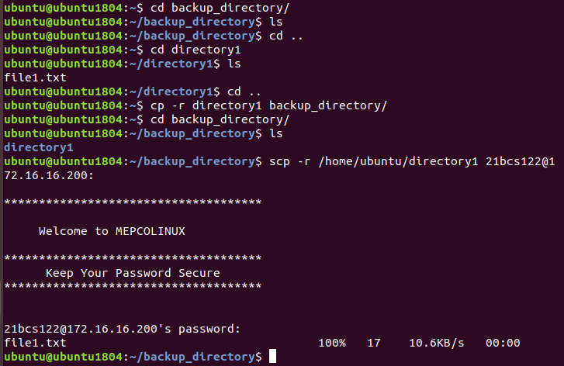

**Problem 2:**

**root@ubuntu1804:/home/ftp2/ftp# ftp 10.0.2.15**

**Connected to 10.0.2.15.**

**220 (vsFTPd 3.0.5)**

**Name (10.0.2.15:ubuntu): ftp2**

**331 Please specify the password.**

**Password:**

**230 Login successful.**

**Remote system type is UNIX.**

**Using binary mode to transfer files.**

**ftp> put file1.txt**

**local: file1.txt remote: file1.txt**

**229 Entering Extended Passive Mode (|||17471|)**

**150 Ok to send data.**

**100% |**************************************************************************| 36 346.28 KiB/s 00:00 ETA**

**226 Transfer complete.**

**36 bytes sent in 00:00 (42.34 KiB/s)**

**ftp> get file1.txt**

**local: file1.txt remote: file1.txt**

**229 Entering Extended Passive Mode (|||50109|)**

**150 Opening BINARY mode data connection for file1.txt (36 bytes).**

**100% |**************************************************************************| 36 1.32 MiB/s 00:00 ETA**

**226 Transfer complete.**

**36 bytes received in 00:00 (57.32 KiB/s)**

**Problem 3:**

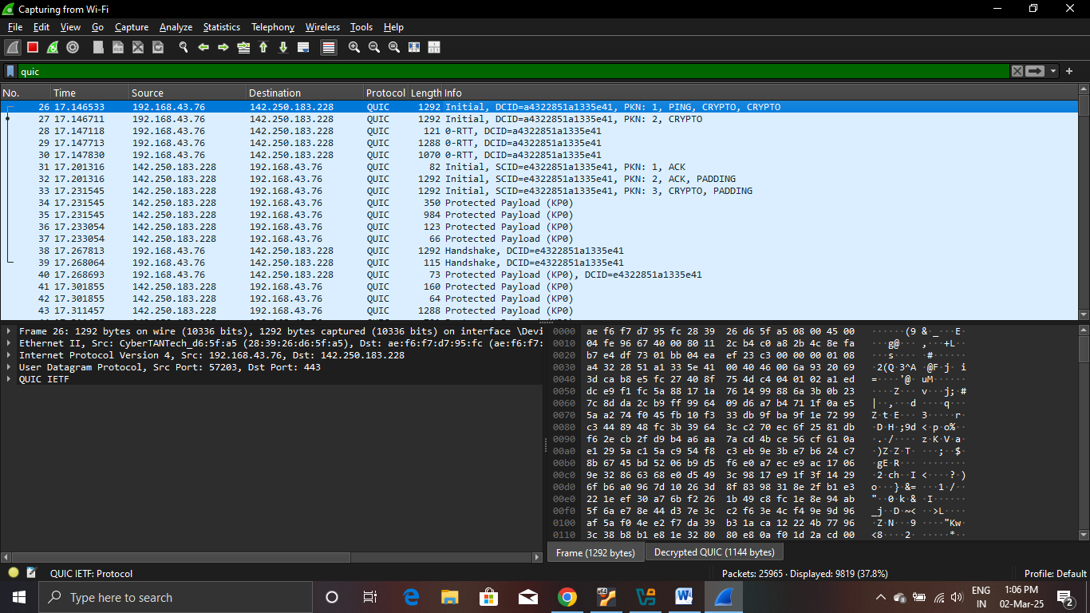

**Problem 4:**

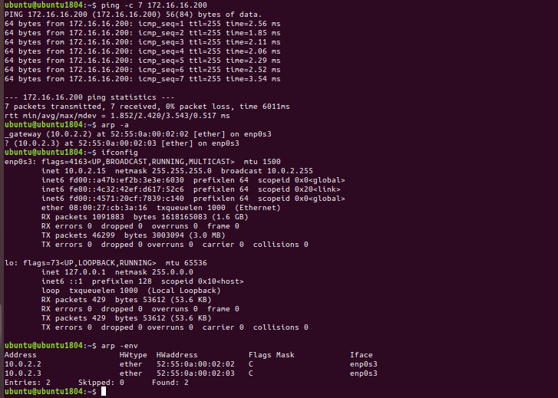

**Problem 5:**

**When two devices have same ip, the arp cache will be corrupted with incorrect MAC to IP mapping.**

**This is because, same ip claimed by different devices leading to packet directed to wrong devices with same ip.**

**This will cause connectivity issues due to error messages and retransmissions.**

**Problem 6:**

1. **Install AnyDesk on both devices.**

**Use the AnyDesk address given by the remote computer to request remote connection.**

**The request must be accepted, or simply set password for access.**

1. **Enable remote desktop in settings of remote computer.**

**Install remote desktop client on your computer.**

**Using the name of remote computer connect remotely.**

**Enter username and password of access of remote computer.**

**Problem 7:**

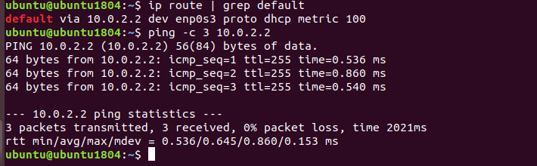

**Problem 8:**

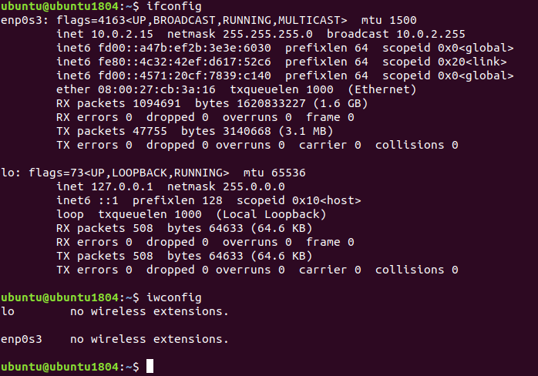

**Problem 9:**

1. **Launch a web browser on your device.**
2. **Enter the router’s IP address in the address bar, typically:**
3. **Log in using the administrator username and password.**
4. **Navigate to the section labeled "Connected Devices," "Device List," or "LAN Status."**
5. **Here, you’ll find a list of all devices currently linked to your network via Wi-Fi or Ethernet.**

**Problem 10:**

**DORA process:**

**Discovery: The device attempting to join the network sends out a broadcast message to request an IP address.**

**Offer: A DHCP server responds with an offer, providing an available IP address from its pool.**

**Request: The device sends a request back to the DHCP server, asking to use the offered IP address.**

**Acknowledgment: The DHCP server confirms and assigns the IP address to the device for a specified duration.**

**Problem 11:**

